

Javascript DOM Assignment



1. Select an <h2> tag with id of text and change its inner text to “Hello World”.

—--------------------Answer—--------------------------------------

<!DOCTYPE html>

<html>

<head>

<title> DOM Assignment</title>

<h2 id="something">Text I want to change</h2>

<script type="text/javascript">

document.getElementById("something").innerHTML = "Hello World!";

</script>

</head>

</html>

—--------------------Answer end---------------------------------------

Before apply JScript

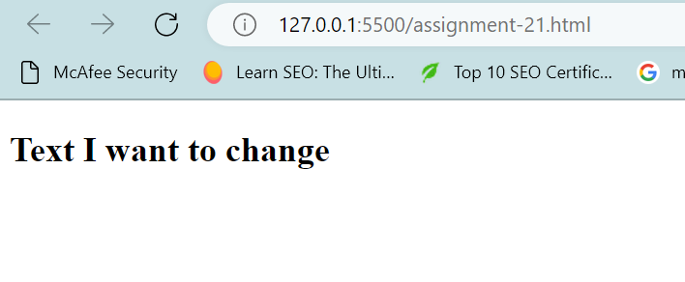

After apply JScript

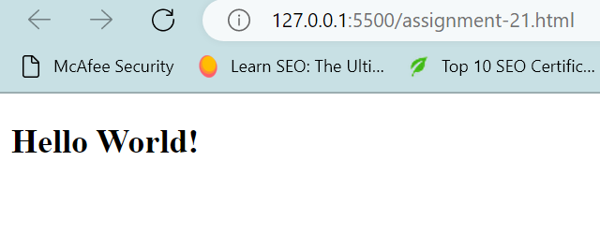

1. Apply following style to the same h2 using Javascript DOM Method.

colour: red, fontWeight: bold,

textTransform: uppercase

—--------------------Answer—--------------------------------------

<!DOCTYPE html>

<html>

<head>

<title> DOM Assignment</title>

<h2 id="something">Text I want to change</h2>

<script type="text/javascript">

document.getElementById("something").innerHTML = "Hello World!";

document.getElementById("something").style.color = 'red';

document.getElementById("something").style.fontWeight = '900';

document.getElementById("something").style.textTransform = 'uppercase';

</script>

</head>

</html>

—--------------------Answer end---------------------------------------

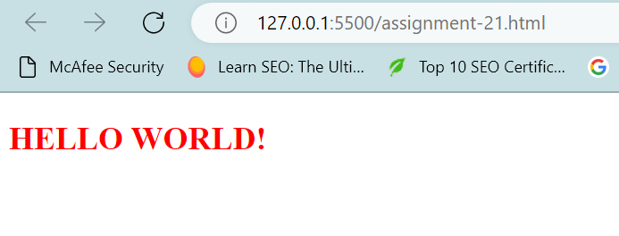

1. Create a simple calculator that takes the input from input1, input 2 and add them together.

<html>

<head>

<meta charset="UTF-8">

<title>Simple Addition Calculator</title>

</head>

<body>

<h1> Addition Calculator(Beta) 🔢</h1>

<div>

<input type="text" id="num-one"> + <input type="text" id="num-two">

</div>

<h2 id="add-sum"></h2>

<script>

var numOne = document.getElementById('num-one');

var numTwo = document.getElementById('num-two');

var addSum = document.getElementById('add-sum');

numOne.addEventListener('input', add);

numTwo.addEventListener('input', add);

function add() {

var one = parseFloat(numOne.value) || 0;

var two = parseFloat(numTwo.value) || 0;

addSum.innerText = one + two;

}

</script>

</body>

</html>

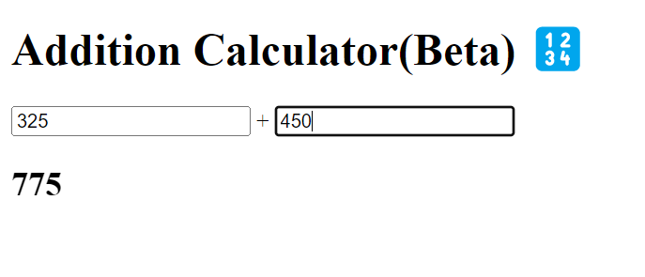

1. What is the error in the following code?

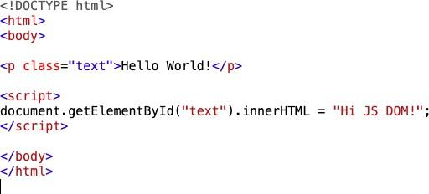

The error in this code is that “text” is initially defined by **class**; and we are trying to change its value through **id argument.**

**The correct code is as below:**

<!DOCTYPE html>

<html>

<body>

<p id="p1">Hello World!</p>

<script>

document.getElementById("p1").innerHTML = "Hi JS DOM!!";

</script>

<p>The paragraph above was changed by a script.</p>

</body>

</html>

1. Using JS Dom select a button and set its onclick event to logging hello in the console.

<!DOCTYPE html>

<html>

<body>

<center>

<h2>HTML DOM onclick Event</h2>

<button onclick="myFunction()">Click me</button>

<p id="demo"></p>

<script>

function myFunction() {

document.getElementById("demo").innerHTML = "Hello";

}

</script>

</center>

</body>

</html>

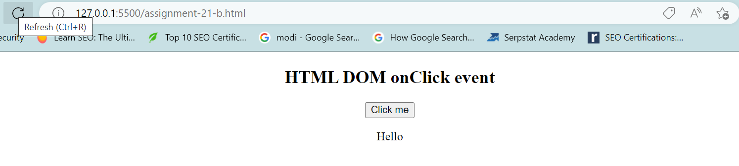

1. Using alert, prevent a person from leaving the screen using JS DOM.

Output -

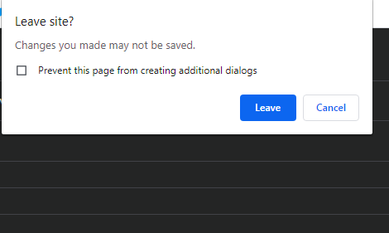

<!DOCTYPE html>

<html>

<head>

<h1 id = "home"> Warn before leaving the page</h1>

<script>

window.onbeforeunload = function(){

return("Do you really want to leave our brilliant application?");

}

</script>

<a href = "https://www.ineuron.ai">Ineuron</a>

</head>

<body>

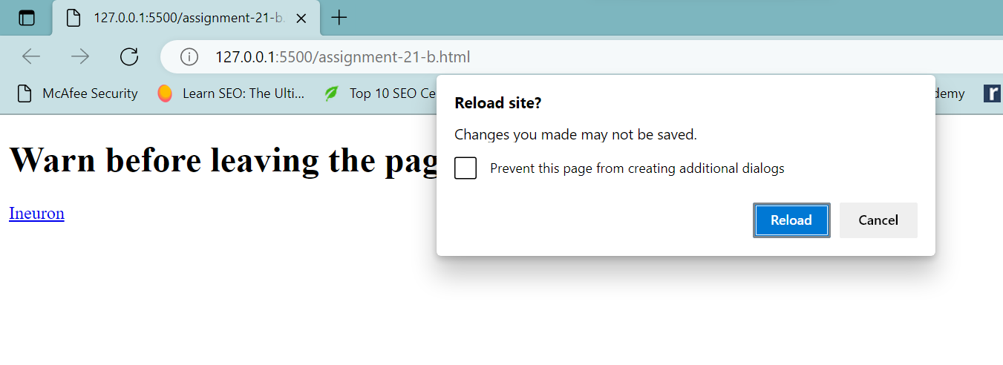

1. Select all the h2 tags on screen and change their colour to purple.

<!DOCTYPE html>

<html>

<head>

</head>

<body>

<h1> The first h1</h1>

<p> Random paragraph text. </p>

<h1> The second h1</h1>

<p> Random paragraph text. </p>

<h1> The third h1</h1>

<p> Random paragraph text. </p>

<h2 id="subHeadline1"> The first h2</h2>

<p> Random paragraph text. </p>

<h2 id="subHeadline2"> The second h2</h2>

<p> Random paragraph text. </p>

<h2 id="subHeadline3"> The third h2</h2>

<p> Random paragraph text. </p>

<script>

document.getElementById("subHeadline1").style.color = "purple";

document.getElementById("subHeadline2").style.color = "purple";

document.getElementById("subHeadline3").style.color = "purple";

</script>

</body>

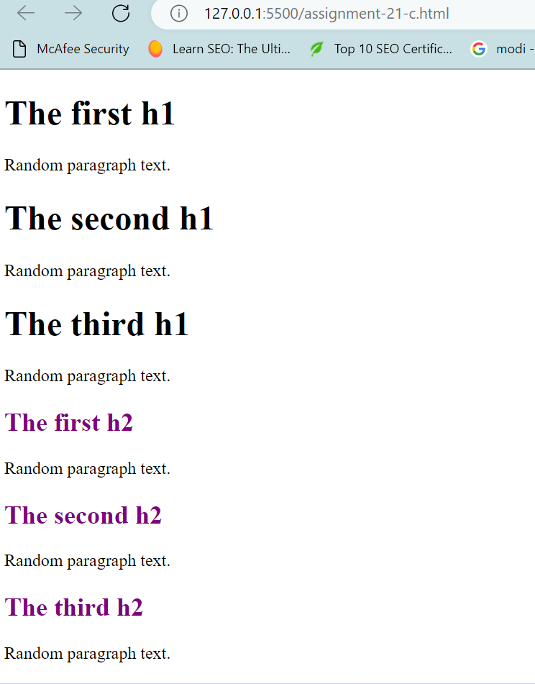

1. Create a new <h4> tag on the screen using JS DOM.

<!DOCTYPE html>

<html>

<body>

<h2>Javascript HTML DOM</h2>

<p> Add a new element</p>

<div id ="div1">

<p id="p1">This is first paragraph </p>

<p id="p2">This is another paragraph</p>

</div>

<script>

const para = document.createElement("h4");

const node = document.createTextNode("This is new h4 element");

para.appendChild(node);

const element = document.getElementById("div1");

element.appendChild(para);

</script>

</body>

</html>

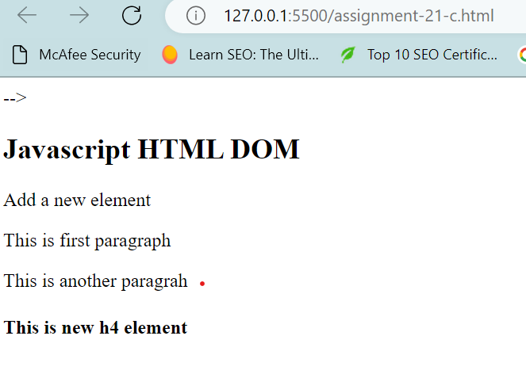

1. Remove an element from the screen using js dom.

<!DOCTYPE html>

<html>

<body>

<h2>Javascript HTML DOM</h2>

<p> Remove an element</p>

<p id="p1">This is first paragraph </p>

<p id="p2">This is another paragrah</p>

<script>

const elmnt = document.getElementById("p1");

elmnt.remove();

</script>

</body>

</html>

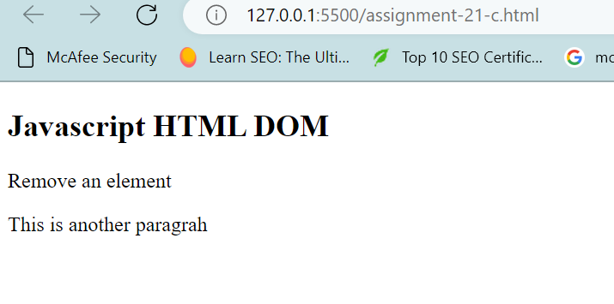

1. Get the number of <p> tags on the screen using JS DOM.

<!DOCTYPE html>

<html>

<body>

<h1>JavaScript HTML DOM</h1>

<p> Finding HTML Elements by Tag Name.</p>

<h1> This is an exercise </h1>

<p> This example demonstrates the <b>getElementsByTagName</b> method. </p>

<h1> The third h1</h1>

<p> Random paragraph text. </p>

<h2 id="subHeadline1"> The first h2</h2>

<p> Random paragraph text. </p>

<h2 id="subHeadline2"> The second h2</h2>

<p> Random paragraph text. </p>

<h2 id="subHeadline3"> The third h2</h2>

<p> Random paragraph text. </p>

<h3 id="demo"></h3>

<script>

const x = document.getElementsByTagName("p");

document.getElementById("demo").innerHTML = "The number of paragraph elements are: " + x.length;

</script>

</body>

</html>

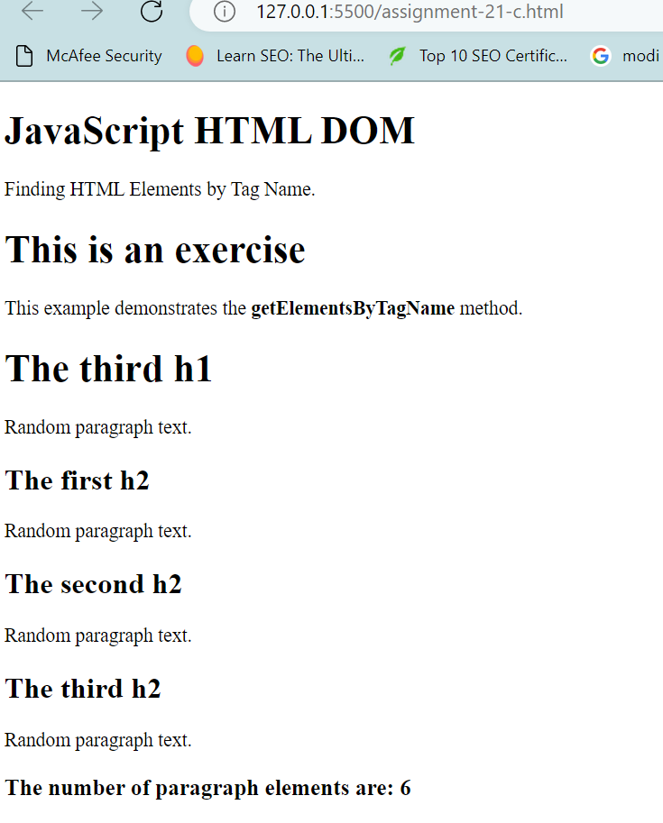

1. Fetch the value of name from the following form.

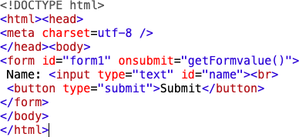

<!DOCTYPE html>

<html>

<head>

<meta charset="utf-8" />

</head>

<body>

<form name = "form" id ="form1" onsubmit="getFormValue()">

Name: <input id ="name" type = "text"> <br>

<button type="submit" value ="Submit">Submit</button>

</form>

<p id = "print"></p>

<script>

var form = document.getElementById("form1");

form.onclick = function (e) {

e.preventDefault();

var name = document.getElementById("name").value;

console.log(name);

document.getElementById('print').innerHTML = name;

}

</script>

</body>

</html>

